Multi-agent systems are fundamentally about organized specialization, ​assigning the right agent to the right task. ​A multi-agent system (or MAS) consists of multiple autonomous entities or agents that ​interact within an environment to achieve individual or collective goals. ​Each agent operates independently, perceiving its surroundings, making decisions, and taking actions.
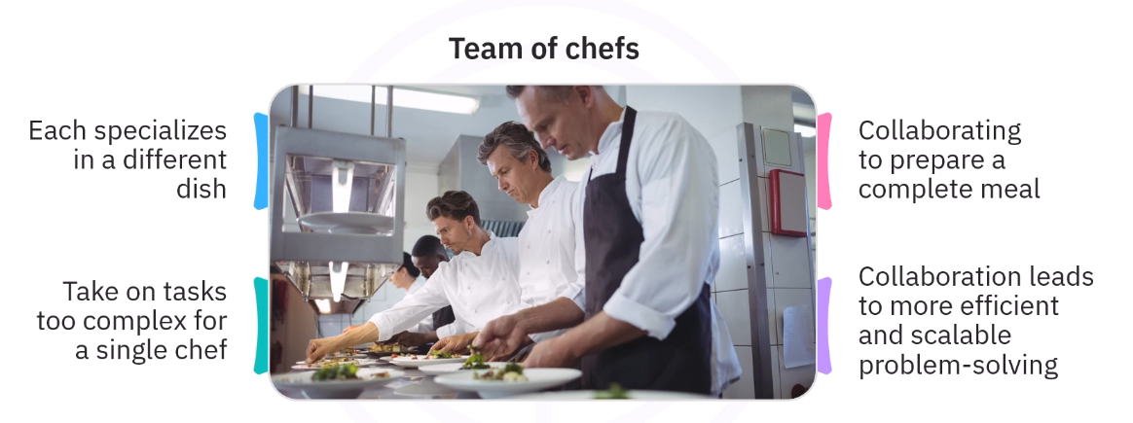

When designing multi-system agents, understanding agent specialization concepts is crucial. ​This involves adhering to several core design principles.
First: Capability Boundaries - ​Each agent should have a well-defined and focused scope. ​For example, a summarizer agent shouldn't be querying databases. ​That's clearly the retriever's job.
Second: Expertise depth vs Breadth - You need to balance highly specialized agents with broad generalist agents. ​These generalists act as coordinators, routing tasks, and monitoring overall progress. ​
Third: Interface Standardization - ​Each agent must communicate through structured inputs and outputs, often using formats like JSON schemas. ​This standardization is what enables effective orchestration ​through frameworks like LangGraph, CrewAI, BeeAI, or AutoGen. ​
Fourth: Handoff Paterns - ​A common example is a document reader agent handing off its output to a summarization agent.
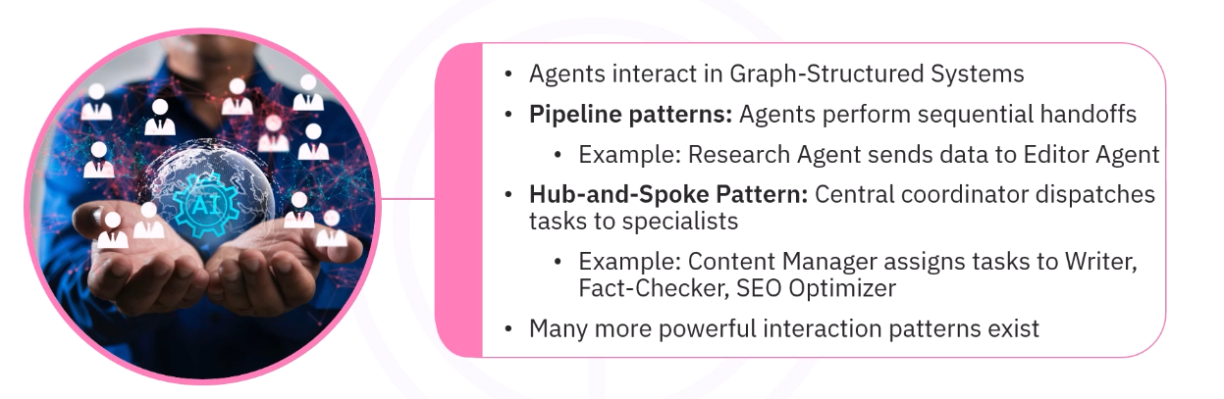

LET’S TALK ABOUT COMMUNICATION PROTOCOL IN MULTI AGENT SYSTEMS:
​Model Context Protocol (or MCP) standardizes how AI models access and share context with ​external tools and data sources, acting as a universal connector for AI applications.
Orchestrating Multi-Agent Systems:
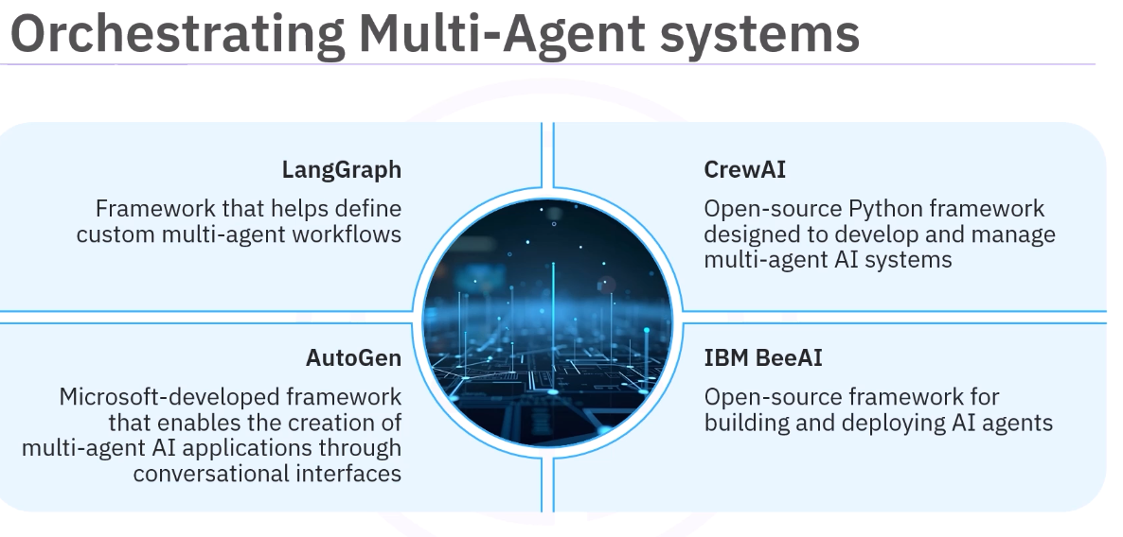
Challenges faced in multi-agent systems:
